Patient 5

Not much PS change for this patient, however it appears even at high PS there is substantial NPV





PS 16

1050 -1850

If anything it looks like NPV at this level and quite consistently where the breaths are recognised

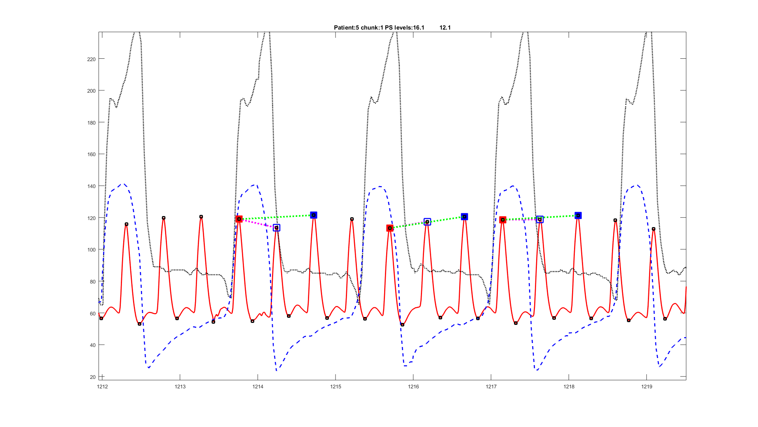

1900- 3450 on the whole the same but a bit noisy and sometimes we get both signals

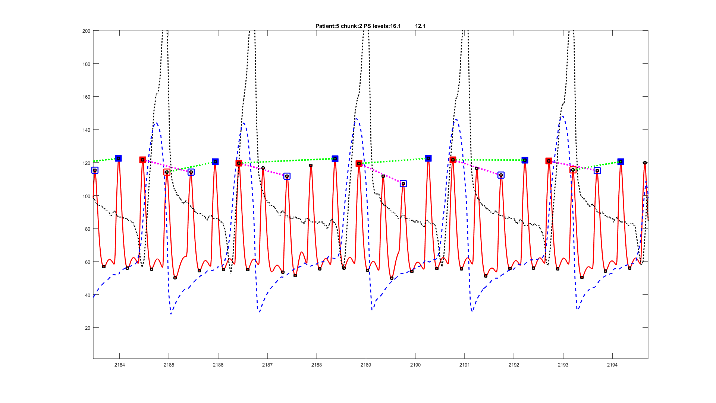

PS = 14

3600 – 4400 Looks a bit like the PS 16 data with the signal going in both directions



PS 16

4600 - 5400 – More of the same

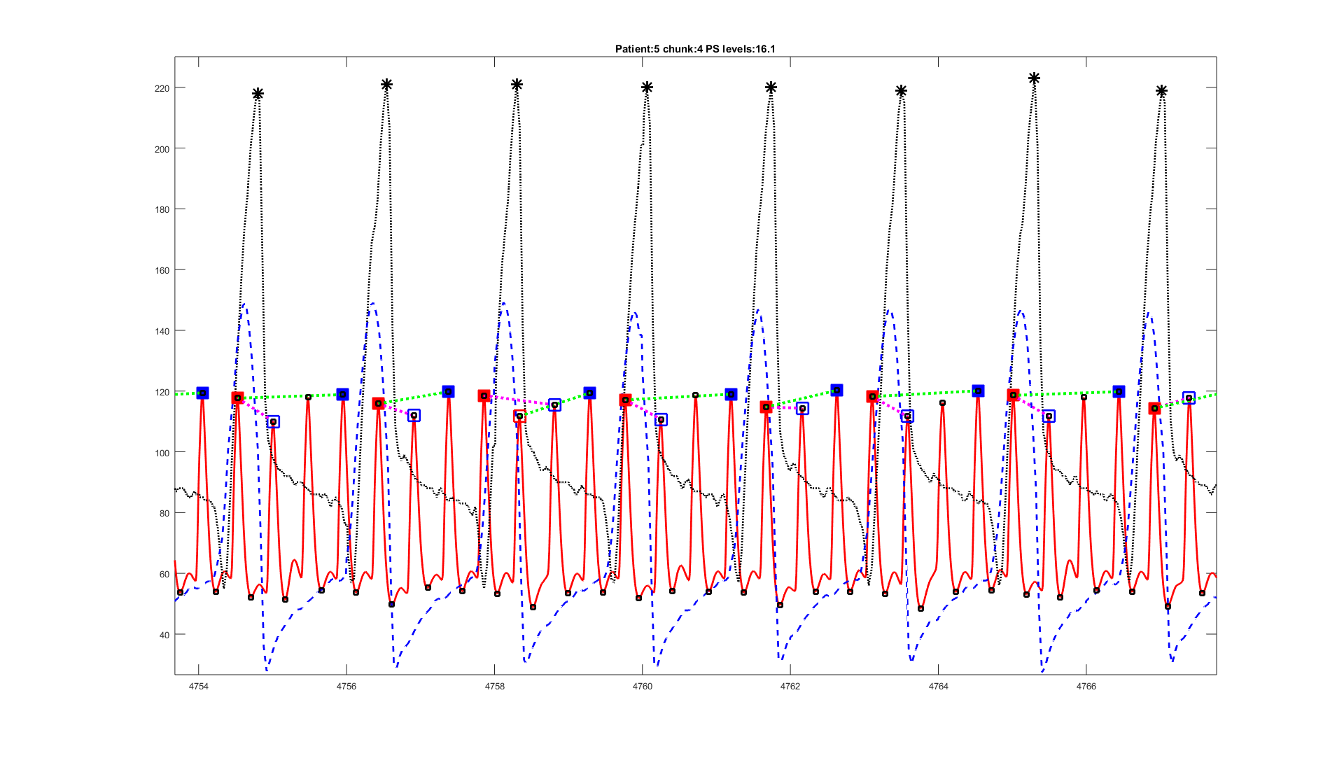

PS 18

5500 - 6700 – a mixed picture again- llots like lots of NPV and lots of PPV slightly offset in time

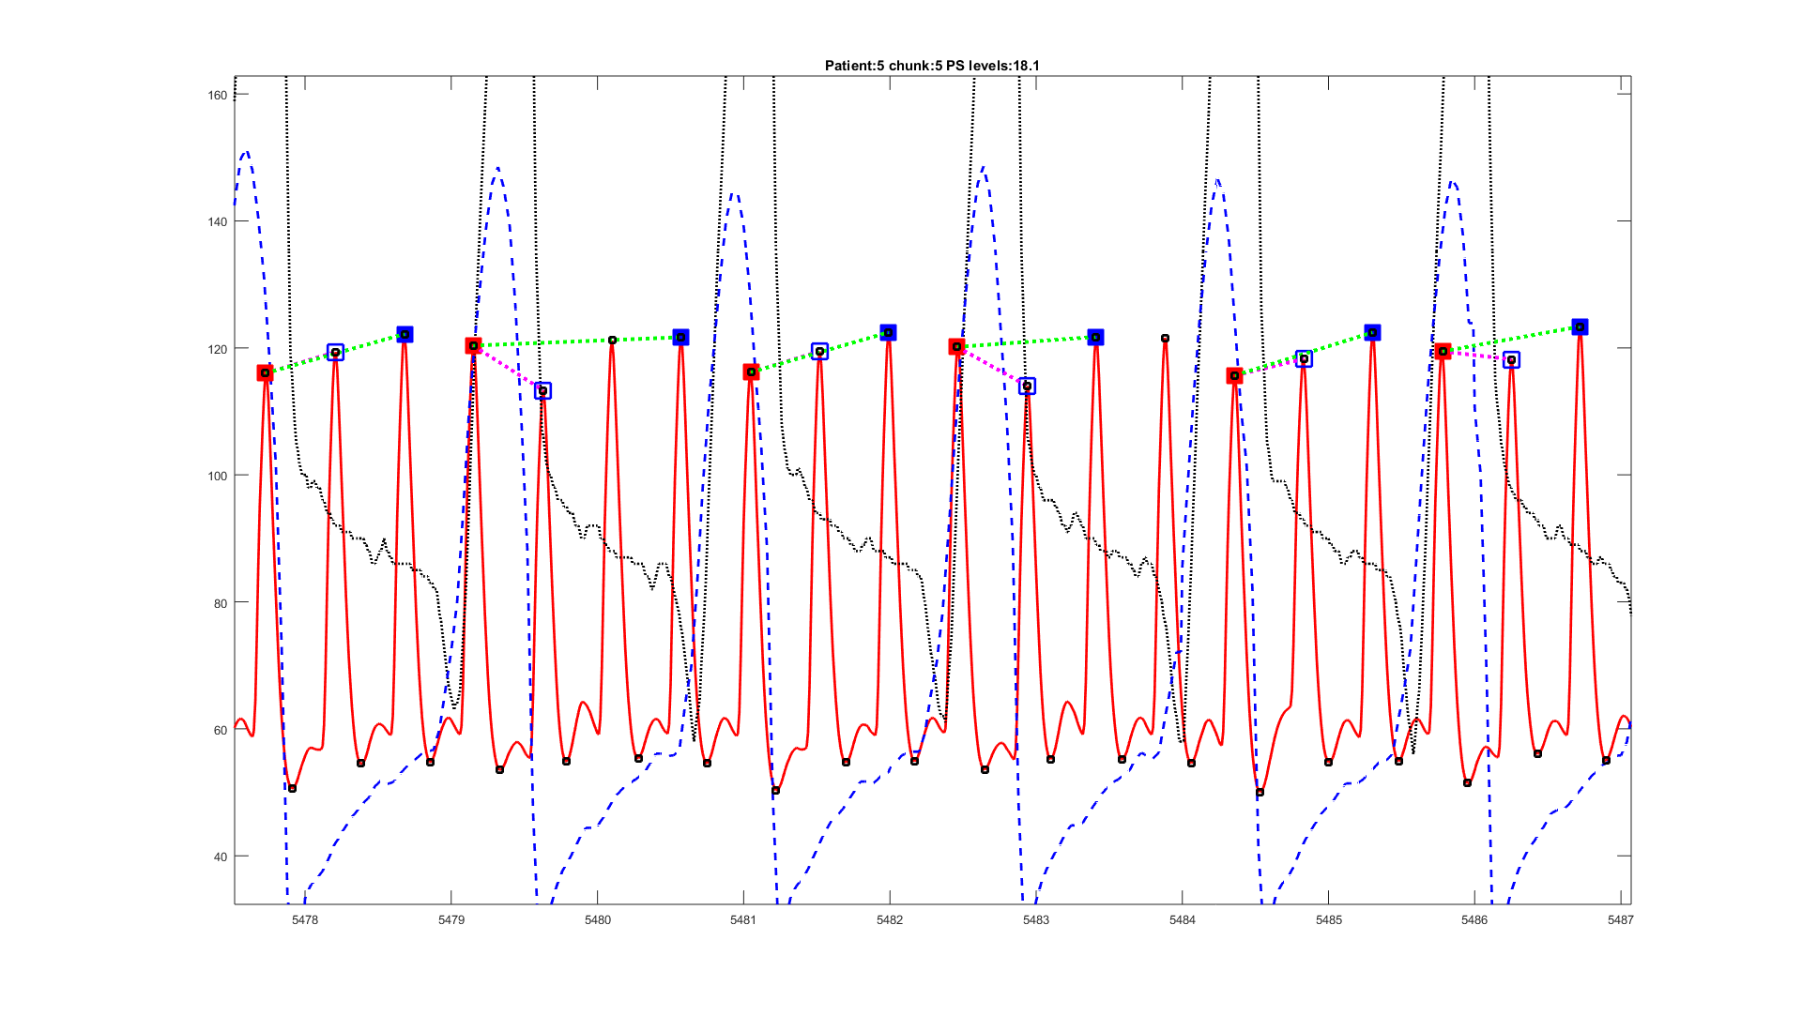

PS 20

6900 – 7850 – A similar picture to other PS levels

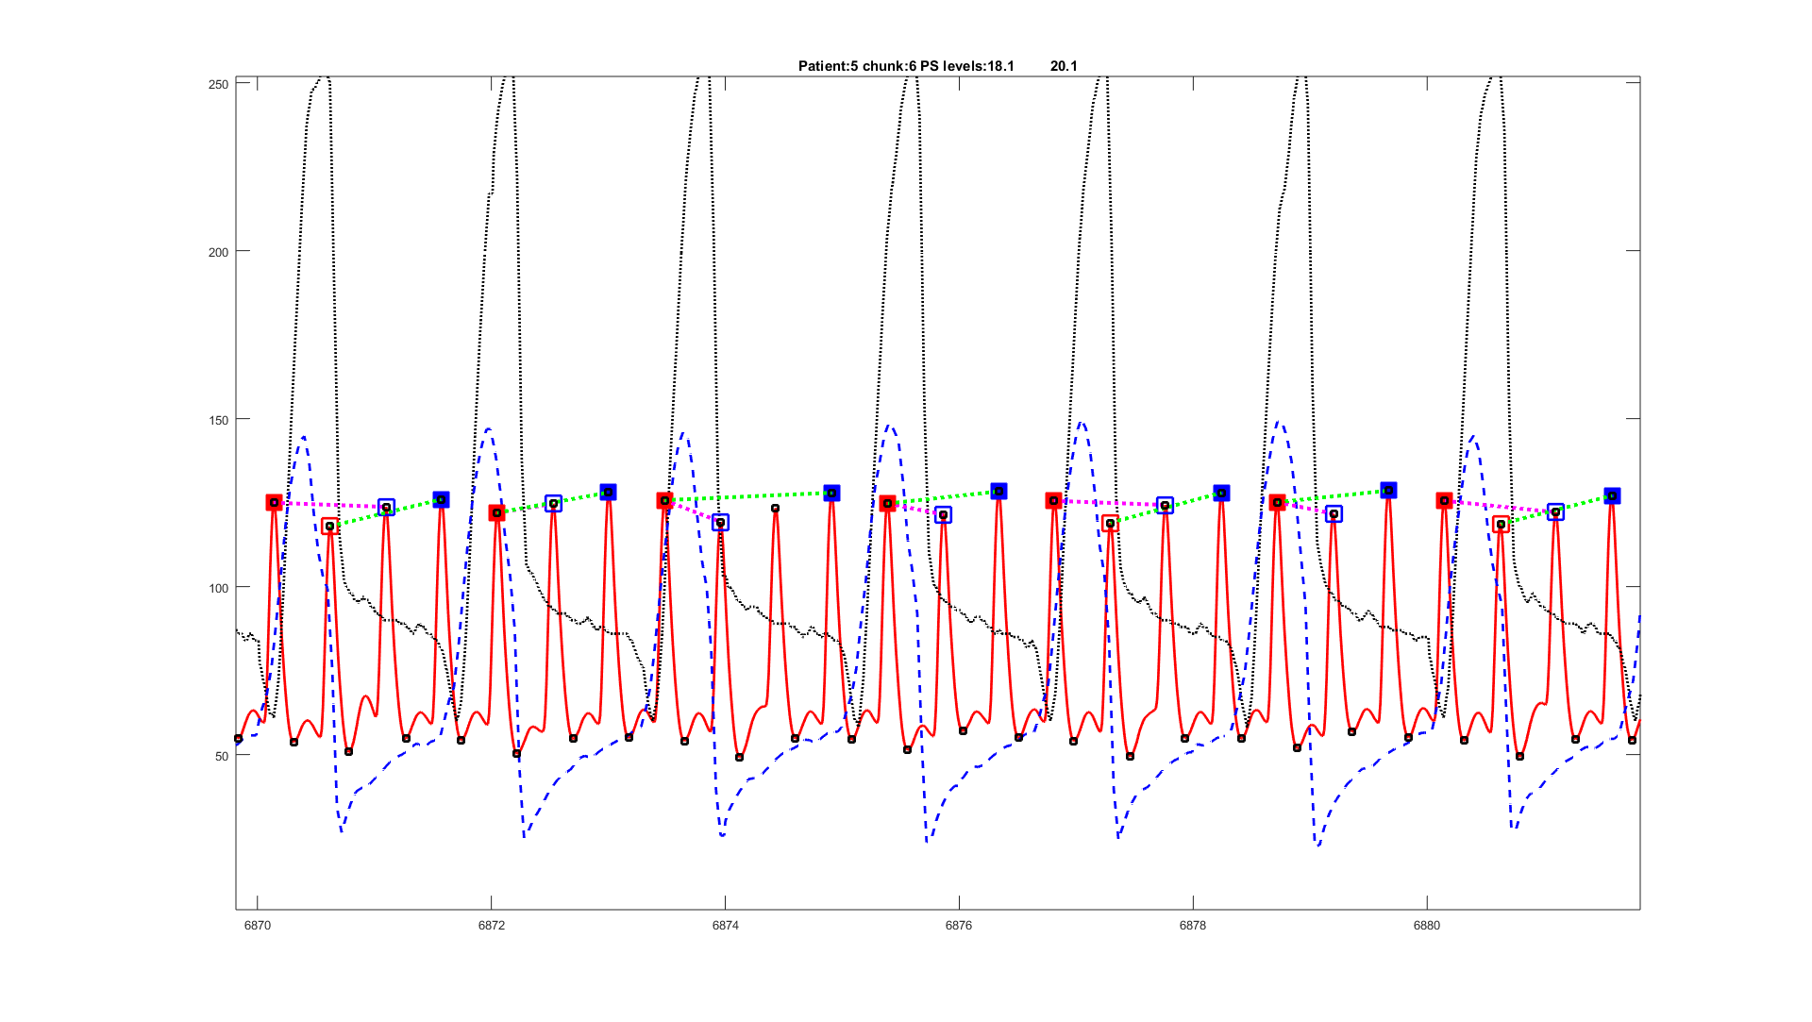

8000 – 8850

Not completed due to issue, but looks like no response

No real muscle activity

